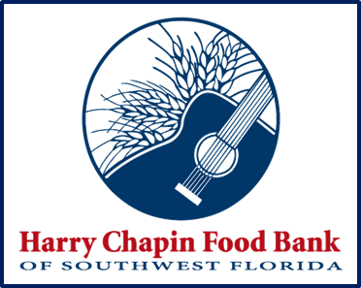
Mobile Pantry

Distribution / Despensa
de Comida Móvil

FARMER’S MARKET STYLE FOOD DISTRIBUTIONS IN
CHARLOTTE COUNTY
Every Thursday as follows:
Human Services at 21500 Gibralter Dr,
Port Charlotte
Every other Thursday, on 7/14, 7/28, 8/11 and 8/25
Cada 2 semanas los Jueves, 7/14, 7/28, 8/11 and 8/25
Sacred Heart at 211 W Charlotte Ave
Every other Thursday, on 7/7, 7/21, 8/4 and 8/18
Cada 2 semanas los Jueves 7/7, 7/21, 8/4 and 8/18
10:00 a.m.—11:30 a.m.
HARRY CHAPIN FOOD BANK IS AN EQUAL OPPORTUNITY PROVIDER
